Experiment 2: Diesel Engine’s Thermal Efficiency
The overall efficiency of an engine to convert the energy contained in the fuel to mechanical work and consequently into electrical power in a generator set depends on the following efficiencies:
- Combustion efficiency
- Thermal efficiency
- Volumetric efficiency
- Mechanical efficiency
In brief, combustion efficiency refers to the efficiency of the combustion process to release the heating content of the fuel; the thermal efficiency refers to the efficiency of the thermal cycle to convert thermal power to mechanical power; the volumetric efficiency refers to the engine’s ability to fill the displacement volume fully by air (air mass affect produced power); and the mechanical efficiency takes into account various friction losses in the engine. A diesel generator set would also have a generator efficiency which refers to the conversion efficiency of the mechanical power to the electrical power.
The objective of this experiment is to compare the theoretical thermal efficiency of a diesel engine with experimentally measured efficiency. The following typical values are assumed for the engine (comment on validity of these assumptions in your lab report):
- Combustion efficiency – Assumed 90-95%
- Thermal efficiency --- Calculated
- Volumetric efficiency – Assumed 80-85%
- Mechanical efficiency – Assumed 85-90%
Carefully review the provided handouts and safety precautions before starting the experiment.

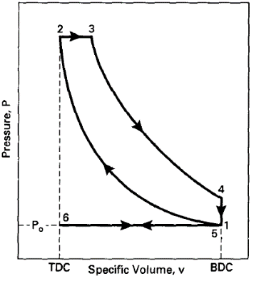
Theory
Figure 1P-v diagram for diesel engine.
The thermal cycle for a diesel engine is shown in Figure 1. Thermal efficiency of a diesel engine may be approximated based on the engine’s compression ratio, r_{c} , specific heat ratio of air, k=1.4, and the cut-off ratio, β, in the diesel cycle:
$(η_{t})_{\text{DIESEL}}=\frac{\left|w_{net}\right|}{\left|q_{in}\right|}=1-{\left(\frac{1}{r_{c}}\right)}^{k-1}\frac{β^{k}-1}{k(β-1)}$ (Eq. 1)
The brake power measure (i.e., the net engine power measured) is the result of all previously mentioned efficiencies:
${\dot{W}}_{b}={\dot{m}}_{f}HVη_{c}η_{t}η_{v}η_{m}$ (Eq. 2)
The compression ratio of the diesel engine is 22 and a cut-off ratio of 2 can be assumed for this lab.
Engine Specifications:
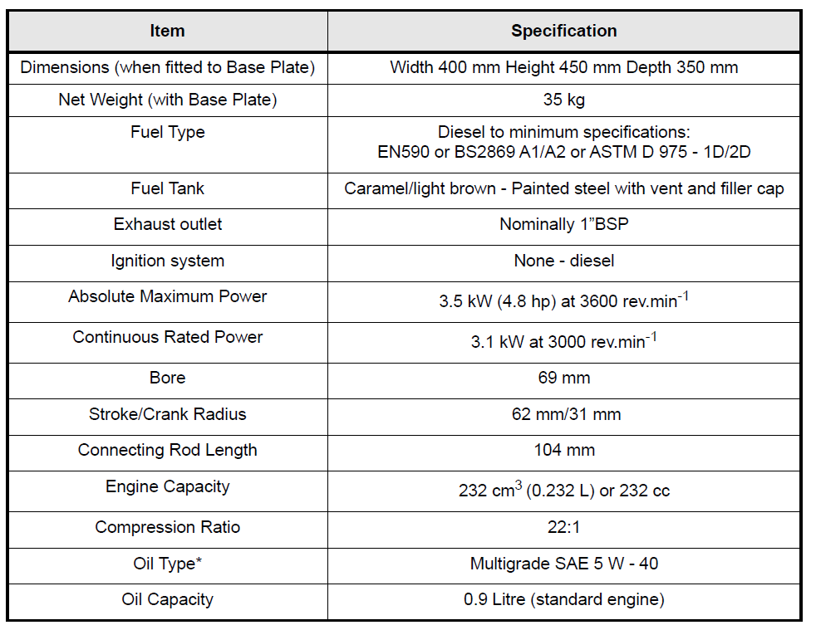
Fuel Specifications:

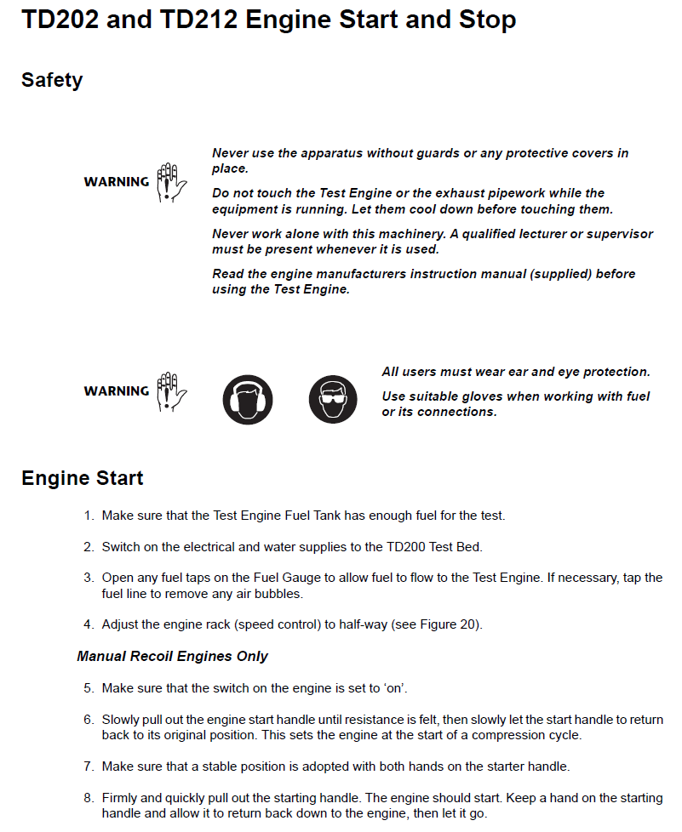
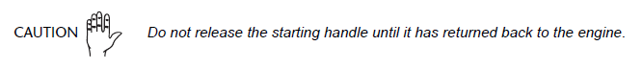

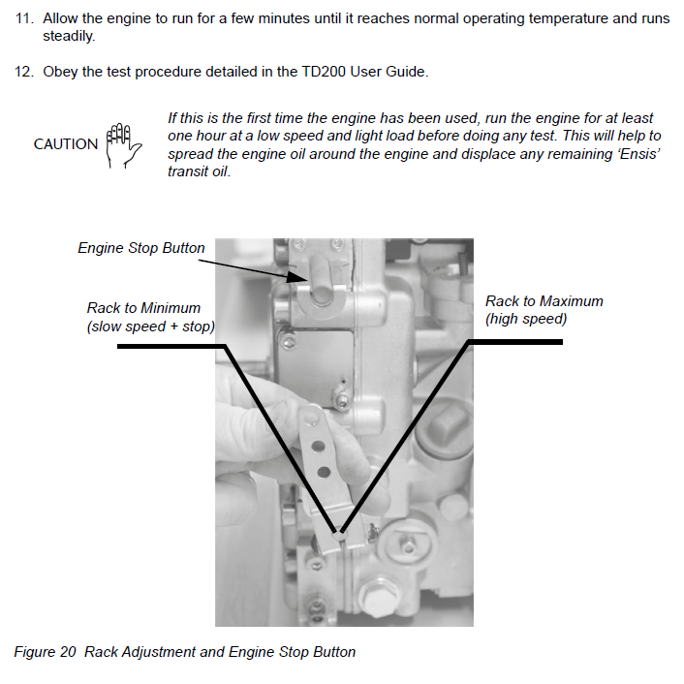
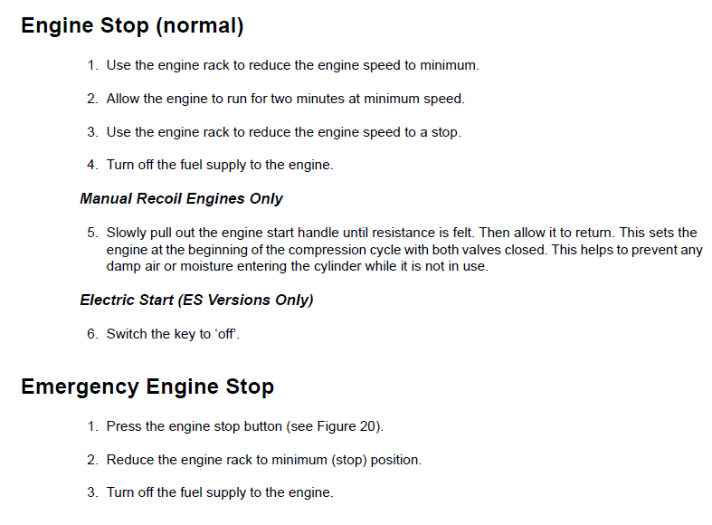

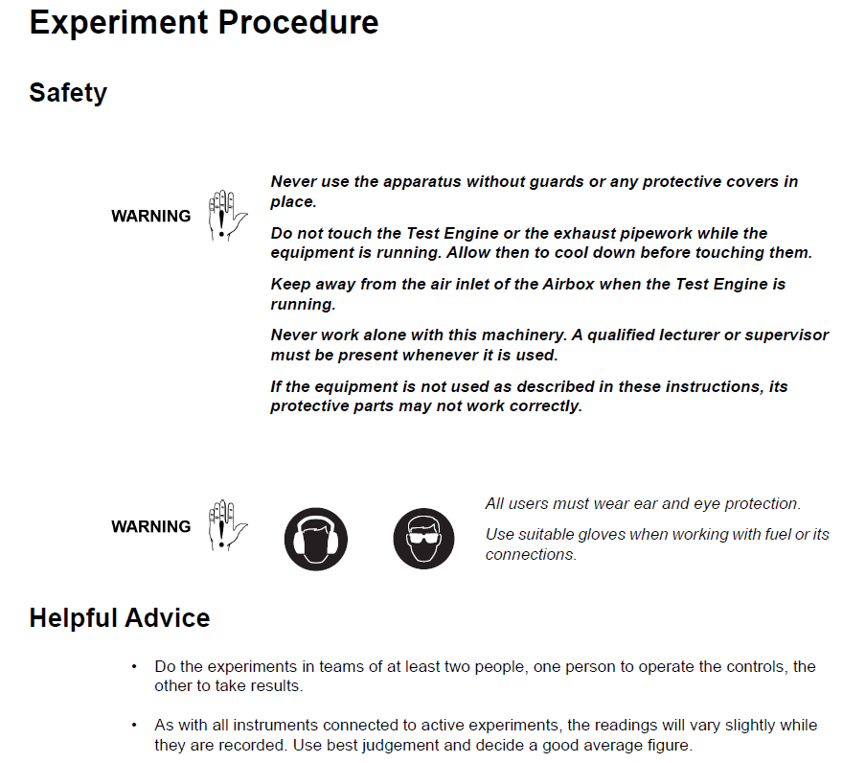

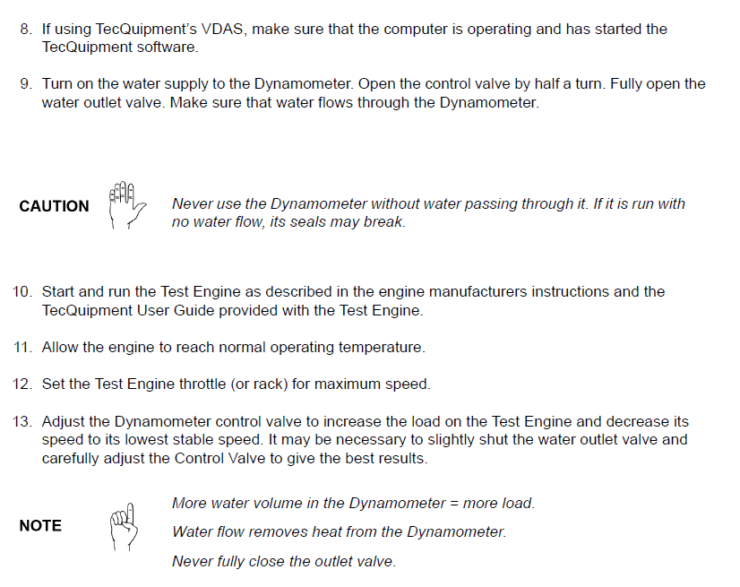
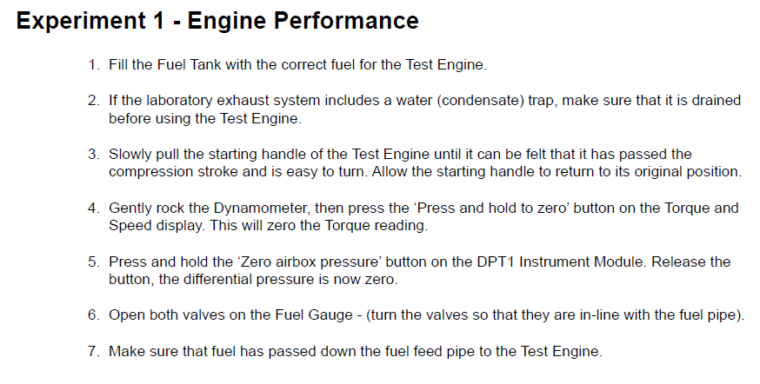
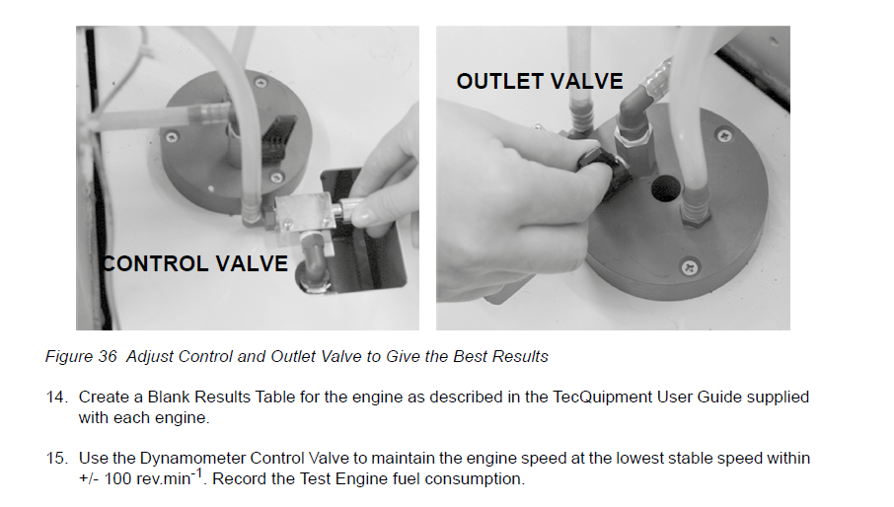

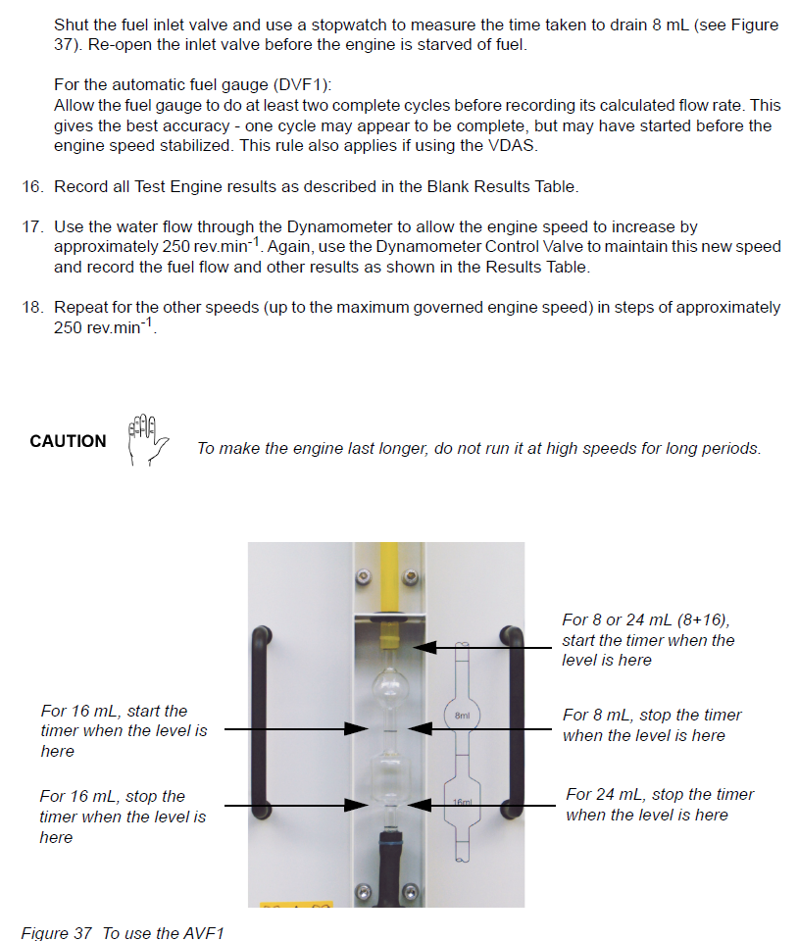

Data Sheet
Obtain at least 6 data points over the following range:
Speed: 1500-3000 rpm
Torque: 9.5-10 N.m
Engine power: 1.5-3kW
